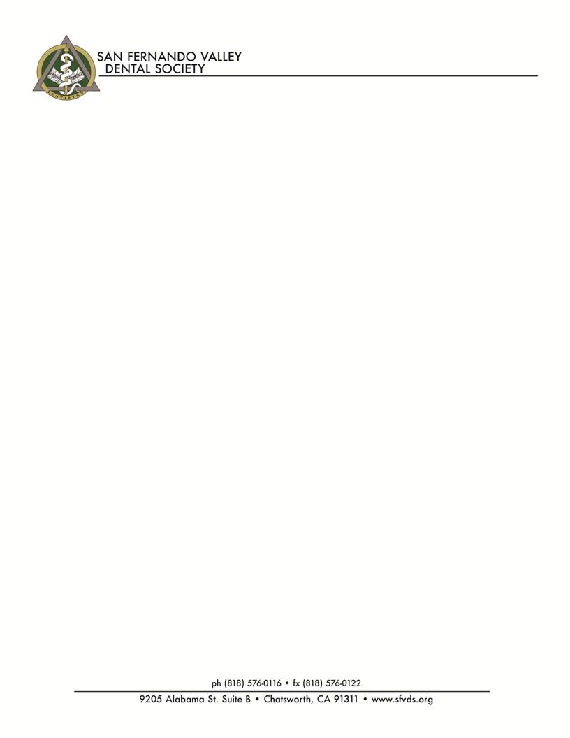

**2017 Exhibitor Registration Form**

Company:_________________________________________________________________________________

Address:__________________________________________________________________________________

___________________________________________________________________________________

Phone:____________________________Fax:____________________________________________________

Email:____________________________________________________________________________________

Contact:__________________________________________________________________________________

Reps:____________________________________________________________________________________

___________________________________________________________________________________

*****

**MEETING SELECTION** *(Circle the date(s) for the meetings at which you wish to exhibit. Please circle those meetings for which you would like to provide a drawing prize to increase dentist traffic to your table.*

*All meetings are held at the Airtel Plaza Hotel, 7277 Valjean Ave, Van Nuys.)*

⁮ ~~January 25~~  ~~⁮ February 22~~ ~~⁮ March 29~~  ⁮ ~~April 26~~

⁮ June 28 ⁮ September 20 ⁮ October 25 ⁮ November 15

□⁮ My company will need an electrical outlet - ***Please bring an extension cord if needed.***

***\*\*All exhibits must be table top only! No Free Standing Displays will be Allowed\*\****

**CHARGES:** *($250 per table per session)*

*\*****Please note.... If you are signing up for a table the day of the meeting there will be $50.00 late Fee\****

⁮ **Season’s Pass: $1500** *(Pre-pay six (6) full-day sessions by January 25, 2017 and receive the 7th & 8th*

*sessions* ***FREE*** *- Plus one* ***free*** *dinner for each meeting.* ***(This is a $780 savings)***

⁮ 1-8 Full Day Sessions: @ $250/session X___ Sessions = $________(Dinner not included)

⁮ Dinners *(Seating with the dentists):* @ $35 each X____= $________

**TOTAL REMITTED**: $____________

⁮ Check enclosed (mail to Wendy Zaslove at the above address)

⁮ Charge my Visa/MC/Discover/Amex credit card (Fax back to: 818.576-0122)

Name as it appears on the CC:_________________________________________

CC#______________________________________________________________

Expiration Date:____________________________________________________

Security Code:_______ Street number of billing address:__________

Zip code of billing address:______________