**GKAS NYC 2023 Frequently Asked Questions**

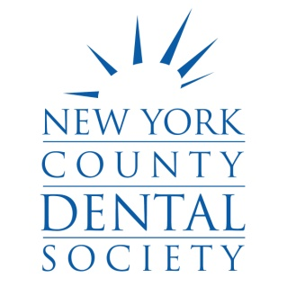 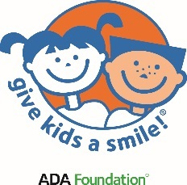

 

1. **What is required of me as a volunteer?**

If you agreed to volunteer you **MUST** show up to the event on time **Friday, February 3, 2023 by 7:30 a.m.** to carry out your assigned duties. We are COUNTING ON YOU.

Be sure to come with a good attitude and be willing to help in any capacity. 😊

1. **What will I actually be doing the day of the event?**

**Dentists** will provide basic dental screenings and providing simple fluoride treatment.

**Non-dentist** volunteers can help by being a scribe to a clinician to record data, usher children to their appropriate areas and more.

1. **What time-frame am I expected to volunteer for the event?**

7:30 AM - 12:30 PM (We may end earlier but be prepared to stay till 12:30 pm.)

1. **What if I can’t attend the Volunteer Orientation on Tuesday, 1/25/23 at 6:00 pm?**

(**Orientation is held at NYCDS, 622 Third Ave., 9th Fl.)**

While it is ideal to attend Orientation (every year the event is a bit different, and this year even more so), you can still volunteer and will be informed via email regarding specific event details in the days prior to the event.

1. **What should I bring to the day of the event?**

**Everyone MUST have photo Identification** **AND proof of vaccination (and wear a mask)** with them the day of the event. We will provide gloves, surgical masks, etc. If you are a dental professional, please bring extra gloves or anything else to assist with a basic exam.

1. **What should I wear to the event as a volunteer?**

The official GKAS NYC 2023 long-sleeve T-shirt OR plain white top and black pants.

1. **Will there be food at the event?**

There will be wrapped breakfast items (and coffee!) available for all volunteers.

1. **Can I bring my staff to volunteer with me?**

Yes, but they must be vaccinated AND they MUST REGISTER through the volunteer form! I

If you want to be at the same site, please indicate in the comment section that you are part of a team of volunteers.

**THANK YOU FOR VOLUNTEERING!**